CS4200 -- Project 1: 8-Puzzle
You can use Java, python or C++

Project Description
The A* search can be used to solve the 8-puzzle problem. As described in the book, there are two candidate heuristic functions: (1) h1 = the number of misplaced tiles; (2) h2 = the sum of the distances of the tiles from their goal positions.
You are to implement the A* using both heuristics and compare their efficiency in terms of depth of the solution and search costs. The following figure provides some data points that you can refer to (you don’t need to report “effective branching factor” in your report). To test your program and analyze the efficiency, you should generate random problems (>100 cases) with different solution lengths or you can use the inputs that I provided to test your program. Please collect data on the different solution lengths that you have tested, with their corresponding search cost (# of nodes generate). A good testing program should test a range of possible cases (2 <= d <= 20). Note that the average solution cost for a randomly generated 8-puzzle instance is about 22 steps.
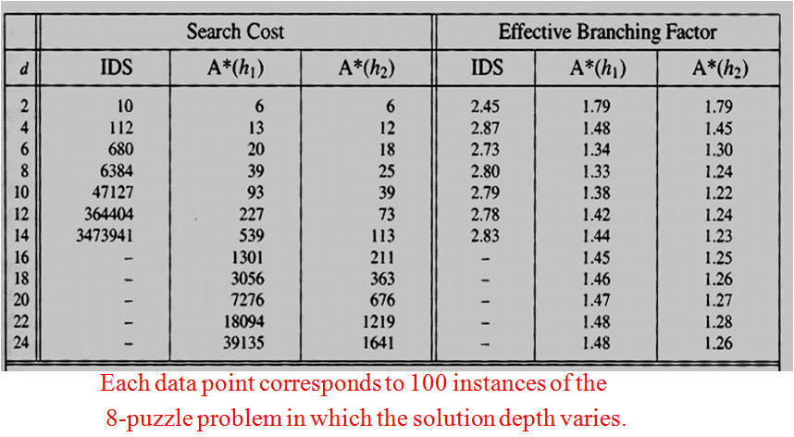
Figure 1 Search Costs for H1 and H2

Input requirements: Your program should implement both of the following: 1) use a random 8-puzzle problem as input; and 2) allow the user to enter a specific 8-puzzle configuration through the standard input, which contains the configuration for only one puzzle, in the following format:
1 2 4
0 5 6
8 3 7
The goal state is:
0 1 2
3 4 5
6 7 8
Where 0 represents the empty tile.
Please handle the input/output gracefully. A sample work is included from prior student work as a reference. Please adhere to the input/output as much as possible.
Note that the 8-puzzle states are divided into two disjoint sets, such that any state is reachable from any other state in the same set, which no state is reachable from any state in the other set. Before you solve a puzzle, you need to make sure that it's solvable. Here's how.
Definition: For any other configuration besides the goal, whenever a tile with a greater number on it precedes a tile with a smaller number, the two tiles are said to be inverted.
Proposition: For a given puzzle configuration, let N denote the sum of the total number of inversions. Then (N mod 2) is invariant under any legal move. In other words, after a legal move an odd N remains odd whereas an even N remains even. Therefore the goal state described above, with no inversions, has N = 0, and can only be reached from starting states with even N, not from starting states with odd N.
GenAI Usage:
GenAI can only be used for debugging in this project.

What to Submit?
- Source code + README (how to compile or run your code).
- Project report (~3 pages, word/pdf format) must include the following discussion:
  - Description of your approach, including a discussion on the data structures you choose for frontier and explored set
  - Comparison of the two heuristics + other analysis + findings), including a table similar to Figure 1 above, without the branching factor, but with new columns about the average run time and the number of cases you've tested with a specific length.
  - Any challenges you encounter or lessons learned.
  - Report any GenAI usage.
- Program output: three sample solutions with different solution depths (<6, between 9 to 15, > 18). Your program should output each step from the initial state to the final state. For your testing purposes, you'll still need to test it with 100 cases and document them in the table.
- Please create a folder called "yourname_4200p1" that includes all the required files and generate a zip file called "yourname_4200p1.zip".
- Please submit your work (.zip) through Canvas. (In case you encounter any Canvas problem during submission, you can send a separate email to the instructor with your submission attached. Please do so by the deadline.)

